I/O CARD- OUTPUT (IOP-DM)
&
Field Termination Card- Digital (FTC-DM)

Hardware Requirement Specification

05-SEP-’13

Ownership Disclaimer
This document contains proprietary and confidential material that is the sole property of Compressor Controls Corporation. The information contained herein is intended for internal use by Compressor Controls Corporation employees and is not intended for distribution outside of the company. As an unpublished work of trade secrets, the recipient shall keep this document confidential. Any re-use, copying, or distribution, either in whole or in part, of this material without the express written consent of Compressor Controls Corporation is strictly forbidden.
Copyright © 2013 by Compressor Controls Corporation. All rights reserved.

Revision History

Rev. | Date | Revised By | Description
0.1 | 05-08-2013 | MILISH JOSEPH | Initial Draft

Approvals

Approved by: Date: _______________
Approved by: Date: _______________
Approved by: Date: _______________
Approved by: Date: _______________
Approved by: Date: _______________
Approved by: Date: _______________

TABLE OF CONTENTS

1 Introduction 5
1.1 Purpose 5
1.2 Audience 5
1.3 Scope 5
1.4 Acronyms 5
1.5 References 5
2 General Description 6
2.1 System Overview 6
2.2 Product Functions 7
2.3 Acceptance Criteria 7
2.4 Dependencies 7
2.5 Block Diagram 8
3 Electrical requirements 10
3.1 CPLD 10
3.2 Clock 10
3.3 EtherCAT Backplane Interface 10
3.4 Digital outputs 10
3.5 Health Circuit of the IOP-DM2 card 11
3.6 Diagnostic Circuit of the IOP-DM2 card 11
3.9 Power 11
3.10 Hot swap 11
3.14 Front Panel LEDs 13
3.15 Debug/ Diagnostic 16
3.16 Components 16
3.17 Connectors 16
4 Mechanical Requirements 17
4.1 PCB 17
5 Not in scope 17
6 Deliverables 17

TABLE OF FIGURES

Figure 1: Block Diagram of NGP System 6
Figure 2: IOP-DO1 to FTC-DM 8
Figure 3: Functional Block Diagram of IOP-DO 9
Figure 3: FTC-DM AND IOP-DM HOTSWAP CIRCUIT 12

Introduction

Purpose
The purpose of this document is to capture the hardware requirements for IOP-DM2 card (I/O Digital inputs card) and FTC-DM2 card. The IOP-DM2 board is used as I/O board for the processing the Digital input signals interfaced to the Field Termination Card (FTC-DM2) in New Generation Platform (NGP) control system.

Audience
This document is meant to be used by the project team members as the basis and controlling document for the design and development of IOP-DM2 and FTC-DM2 card.

Scope
The scope of this project is to design and develop the NGP boards where IOP-DM2 and FTC-DM2 board are used to process the Digital inputs and Frequency inputs. This document defines the product requirements to which hardware has to be designed and manufactured. This document also covers system level requirements applicable to IOP-DM2 and FTC-DM2 cards. This document doesn’t cover the firmware/ software related requirements.

Acronyms
Acronym | Definition
FTC | Field Termination Cards
ESC | Ethernet slave controller
IOP | Input Output Processor
DM | Digital Module

References
[1] Detailed Functional Specification for NGP Hardware, Part 1, Rev-3
[2] System Study for New Generation Platform Electronics and Bring-up, Rev-1
[3] Vaguard_Theory Of Operation_Healthy Logic.pdf from CCC

General Description

System Overview
New Generation Platform (NGP) is a fully redundant, duplex, highly available, fault tolerant control system intended to handle a number of digital, analog and frequency IOs in industrial applications. Below is the system block diagram of NGP.

Trainlink2 A/B
PCC
APP
B
B
IOP-xxx
4A
IES
IOP-xxx
IOP-xxx

IOP-xxx
IOP-xxx
IOP-xxx
6B
B
6A
5A
5B
4B
IOP-xxx
IOP-xxx
IOP-xxx
IOP-xxx
IOP-xxx
IOP-xxx
3B
3A
2B
1B
2A
1A
PCC
APP
IES
A
A
A
SAC
EES
FTC-xxx
FTC-xxx
FTC-xxx
FTC-xxx
FTC-xxx
FTC-xxx
EEC
EEC
Trainlink2 A/B
ECAT
Trainlink1 A/B
SAC
SAC

Figure 1: Block Diagram of NGP System

Here is the list of different electrical components in the system and their brief description.

IOP (Digital and Analog)
These are the processors cards which handle digital, analog and frequency IOs. There will be a maximum of 12 such cards in an NGP system.

APP
This is the main processing unit in the system. This runs the main application and does monitoring and control of the overall system. There will be a maximum of 2 such cards in an NGP system.

IES
This is the EtherCAT switch card used to interface between different APP and IOP modules. There will be a maximum of 2 such cards in an NGP system

PCC
This is power conversion card. The input power (redundant 24VDC) to the system first comes to this card. This card does the ORing, filtering, protection and other voltage conversion. There will be a maximum of 2 such cards in an NGP system

FTC (Digital and Analog)
These are the field terminal cards where all the field loads are connected to. These are electrically interfaced to IOP cards.

CAC
These are the set of communication (Ethernet, RS-485) cards used for interface to the external devices

Backplane
All the above mentioned boards plug in backplane and communicate to each other over it.

Product Functions
IOP-DM2 card is used for processing the Digital input and Frequency Input signals from the Field Termination cards. It also implements the EtherCAT master to communicate to IES card in the NGP system.

Acceptance Criteria
Mindteck shall design, develop and deliver the hardware meeting the functionalities as detailed in section 6.0

Dependencies
- Finalization of all components and connectors shall be approved by CCC.
- PCB form factor from CCC
- About 10% time from a CCC’s representative for addressing queries, reviews and acceptance
- Timely inputs, reviews and approvals
- Assistance in the finalization of all the requirements specification documents
- Validation testing and approval of prototypes.

Block Diagram
The block diagram shows the communication between the IOP-DM(OUTPUT ) cards and the FTC-DM(OUTPUT) card. Each FTC-DM2 is accessible to two IOP-DM2 cards for realizing the duplex feature. Mainly the IOP-DM2 cards process the Digital output signals received over the backplane from the FTC-DM2 cards..

IOP-DM2 CARD1
IOP-DM2 CARD2
Daughter Board
Daughter Board

Back Plane

FTC-DM2 Card

16
3

Digital Output

Figure 2: IOP-DO1 to FTC-DM

The functional block diagram for the IOP-DM2 card is shown below.

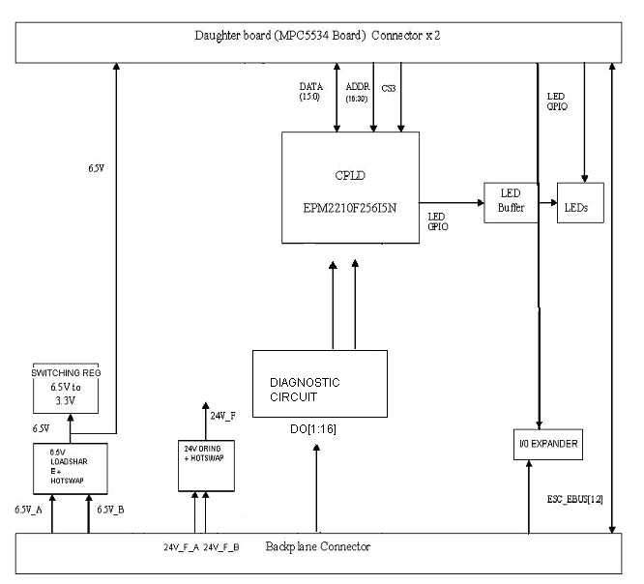
Figure 3: Functional Block Diagram of IOP-DO

The daughter board inside the IOP card acts as the main processing unit for the Digital inputs and Frequency inputs. The daughter board shall be built on Freescale MPC5534 microcontroller. It shall provide interfaces to various memories and implements Ether CAT slave controllers to communicate to IES cards in the system. Please refer Hardware requirement specifications for MPC5534 daughter board for more detailed requirement specifications.
EEPROM

3 Electrical requirements

3.1 CPLD
The IOP DM2 board shall use EPM2210F256I5N from Altera as the CPLD. The read back logic of digital IOs shall be implemented in the CPLD. It is accessible to MPC5534 through the external bus interface chip select3.

Clock
The CPLD shall be provided an external clock with a frequency of 40MHz.

EtherCAT Backplane Interface
The IOP shall route signals from two EherCat ports in MPC5534 board to the IES through the backplane connector.

Digital outputs
Enable
In IOP-DM2,

There will be 16 digital outputs to the IOP-DM(DO) board. Digital output signals are coming from the FTC to the backplane. The diagnostic circuit diagnosis any fault during an improper switching. These signals are read back by the CPLD and then indicated by LEDS to show the active and fault status of each digital output

In FTC-DM2,

The digital output signals are coming from 16 relay coils in FTC-DM(DO). They are then routed to the IOP-DM through the backplane. The FTC-DM bottom should support both FTC_DM(DO) and FTC-DM(DI) top boards

Health Circuit of the IOP-DM2 card
The Health circuit logic shall be implemented in CPLD in match with the IOP_AM considering the following inputs

Conditions to say that card is healthy.

- Signals indicating the presence of APP cards derived from the EtherCAT slave controllers.
- Signals driven by MPC5534 like RESET/, RSTOUT/, Power_health/ and temperature sensor signals.

Diagnostic Circuit of the IOP-DM2 card
The IOP and FTC boards shall provide proper diagnostic circuits for the diagnosis of fault/ active condition of digital inputs/ outputs.

Power
The IOP and FTC Boards shall be supplied with following voltages:

- The IOP-DM shall receive 6.5V_A ,6.5V_B,24V_A and 24V_B from the power connector. These power supplies shall be used for powering up digital output circuits , CPLD, Digital input circuits and frequency input section after isolation.

- 24V Digital supply: 24V_D_A and 24V_D_B will be ored in the ftc-dm and will be shared to IOP-DM A and IOP-DM B.

Hot swap
IOP-DM
Hot swappable controller will be used at the Input power supply for 6.5V , 24V generated from PCC. On board reset will be generated during card plug-in and removal. The connectors to be back plane will be having staged pins so that the GND contact can be established at first during the live insertion.

The FTC_DM circuit also provides hotswap for 24V_D and 24V_F signals as follows.

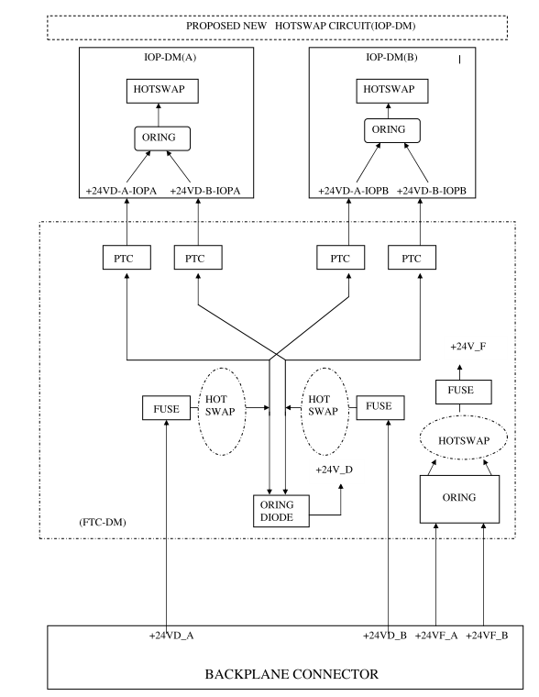
Figure 4: FTC-DM AND IOP-DM HOTSWAP CIRCUIT

3.12 LOAD SHARE

Load sharing will be provided for 6.5V signal. The IC will allow 6.5V A and B to be load sharable within in the tolerance limit

3.13 ORING

Oring circuit will be used for 24F_A and 24F_B . So the IOP-dm will be able to be powered from either 24V_A and 24V_B

3.14 Front Panel LEDs
The IOP board shall provide following LEDs

Name | Function |  | Color
POWER | Power Supply(ies) status ok |  | Blue-CCC
ACTIVE | Card is controlling output channels |  | Green
READY | Card is healthy and has no detectable faults |  | Green
ALARM | Card has a detectable non-critical issue |  | Yellow
FAULT | Card has a critical error |  | Red
CPU | CPU is active/heartbeat |  | Green
LEARN | Card in initializing/booting/learning from peer |  | Green
ESC1 Link/activity | Indicates the Link/activity status for ESC1 |  | Green
ESC2 Link/activity | Indicates the Link/activity status for ESC2 |  | Green
ESC1 Run | Indicates the RUN status for ESC1 |  | Green
ESC2 Run | Indicates the RUN status for ESC2 |  | Green
DO1_ACTIVE | Indicates the active status of Digital output 1 |  | GREEN
DO2_ACTIVE | Indicates the active status of Digital output 2 |  | GREEN
DO3_ACTIVE | Indicates the active status of Digital output 3 |  | GREEN
DO4_ACTIVE | Indicates the active status of Digital output 4 |  | GREEN
DO5_ACTIVE | Indicates the active status of Digital output 5 |  | GREEN
DO6_ACTIVE | Indicates the active status of Digital output 6 |  | GREEN
DO7_ACTIVE | Indicates the active status of Digital output 7 |  | GREEN
DO8_ACTIVE | Indicates the active status of Digital output 8 |  | GREEN
DO9_ACTIVE | Indicates the active status of Digital output 9 |  | GREEN
DO10_ACTIVE | Indicates the active status of Digital output 10 |  | GREEN
DO11_ACTIVE | Indicates the active status of Digital output 11 |  | GREEN
DO12_ACTIVE | Indicates the active status of Digital output 12 |  | GREEN
DO13_ACTIVE | Indicates the active status of Digital output 13 |  | GREEN
DO14_ACTIVE | Indicates the active status of Digital output 14 |  | GREEN
DO15_ACTIVE | Indicates the active status of Digital output 15 |  | GREEN
DO16_ACTIVE | Indicates the active status of Digital output 16 |  | GREEN
DO1_FAULT | Indicates the active status of Digital output 1 |  | RED
DO2_FAULT | Indicates the active status of Digital output 2 |  | RED
DO3_FAULT | Indicates the active status of Digital output 3 |  | RED
DO4_FAULT | Indicates the active status of Digital output 4 |  | RED
DO5_FAULT | Indicates the active status of Digital output 5 |  | RED
DO6_FAULT | Indicates the active status of Digital output 6 |  | RED
DO7_FAULT |  | Indicates the active status of Digital output 7 | RED
DO8_FAULT |  | Indicates the active status of Digital output 8 | RED
DO9_FAULT |  | Indicates the active status of Digital output 9 | RED
DO10_FAULT |  | Indicates the active status of Digital output 10 | RED
DO11_FAULT |  | Indicates the active status of Digital output 11 | RED
DO12_FAULT |  | Indicates the active status of Digital output 12 | RED
DO13_FAULT |  | Indicates the active status of Digital output 13 | RED
DO14_FAULT |  | Indicates the active status of Digital output 14 | RED
DO15_FAULT |  | Indicates the active status of Digital output 15 | RED
DO16_FAULT |  | Indicates the active status of Digital output 16 | RED

3.15 Debug/ Diagnostic
3.15.1 JTAG Port
JTAG port shall be implemented to test chip functionality and connectivity and also device programming.
The JTAG connector will be a board edge type so that it can be easily mounted on to the pcb

    - Test Points
Clip-on test points shall be implemented for key signals including all power and ground rails. The test points should be reasonably spaced to prevent test connection shorting while testing.
    - Logic Analyzer Connection
Logic analyzer connection port shall be implemented for debugging.

Components
    - All the components shall meet industrial temperature ratings
    - Any BGA parts used shall be Non-RoHS
    - All other parts can be either RoHS or Non-RoHS

Connectors

    - IOP-DM2 to back plane

Make | Part No | Description
FCI | 10045267-101LF | 72-PIN Air-Max
FCI | 10061289-001LF | 4-PIN Power connector
FCI | 10045597-105LF | GUIDE PIN

    - IOP-DM2 to MPC5534 Daughter board

Make | Part No | Description
Samtec | QTE-040-02-X-D-A | 80-PIN,Male Shroud Contacts

    - FTC – DM2 to Backplane

Make | Part No | Description
FCI | 10056098-1050011LF | 150-PIN Air-Max

Mechanical Requirements

4.1 PCB

4.1.1 PCB Thickness

The PCB thickness of the IOP Digital Board shall be 1.6mm.

5 Not in scope

- User manual, tutorial or any other user documentation
- Certification, environmental, ATEX testing, EMI/EMC testing

6 Deliverables

Mindteck shall deliver the following hardware deliverables as per the project plan for CCC review and acceptance…

- Hardware Requirements Specifications document
- Hardware Design Document
- Backplane board schematics design files
- Board Layout files & Gerber files
- Backplane board Bill of Materials
- Tested prototypes
- Test reports

